**How to realize a Piezo-resistive pressure sensor using surface Micromachining**

In Intellisuite software

* You realize the structure,

i.e, fabricating the structure from scratch

Fabrication is generally of two types

Surface Micromachining

* Succession of thin film deposition with selective etching
* i.e a silicon wafer and you build on it.

Bulk Micromachining

* Bulk substrate being selectively etched here and there to produce the device.

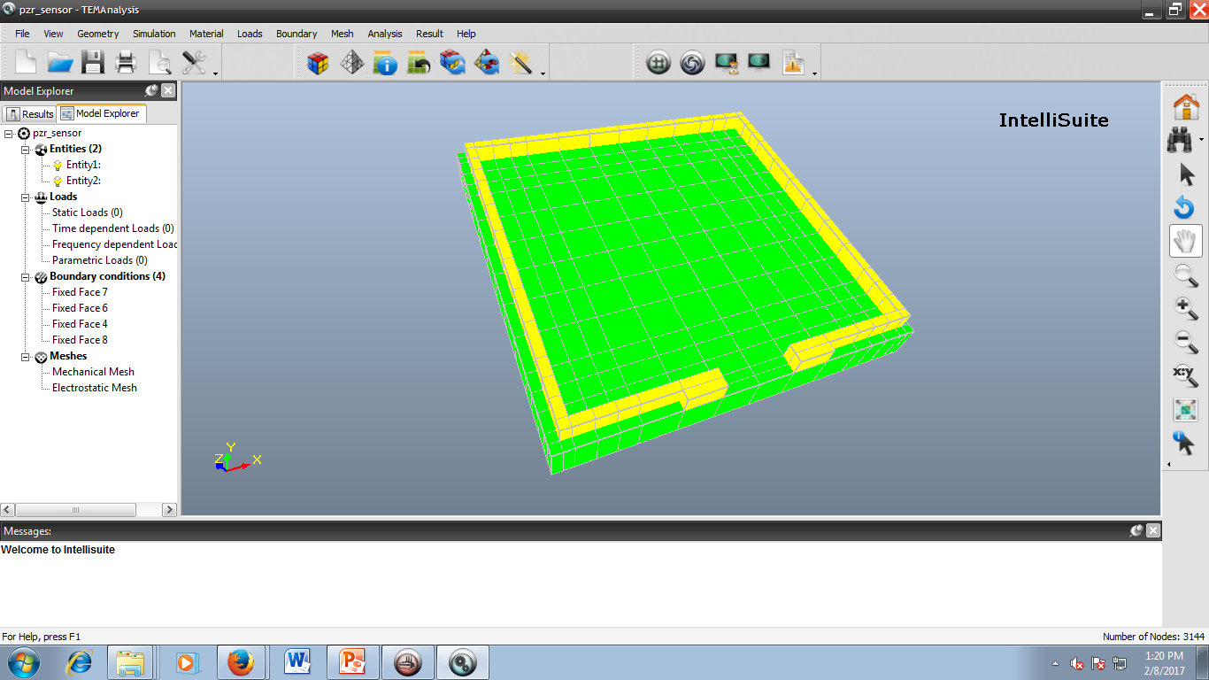

Piezo resistive material

Silicon substrate

In COMSOL MULTIPHYSICS software,

* you draw your device structure directly
* Start the respective analysis.

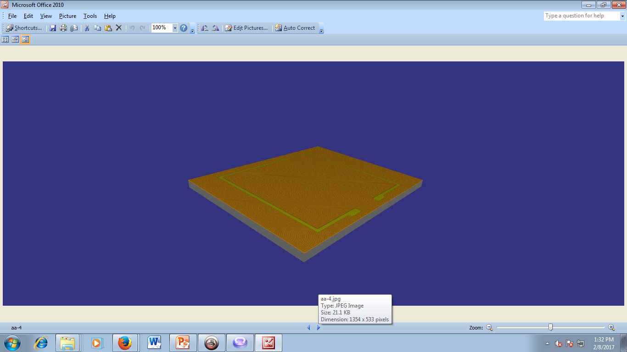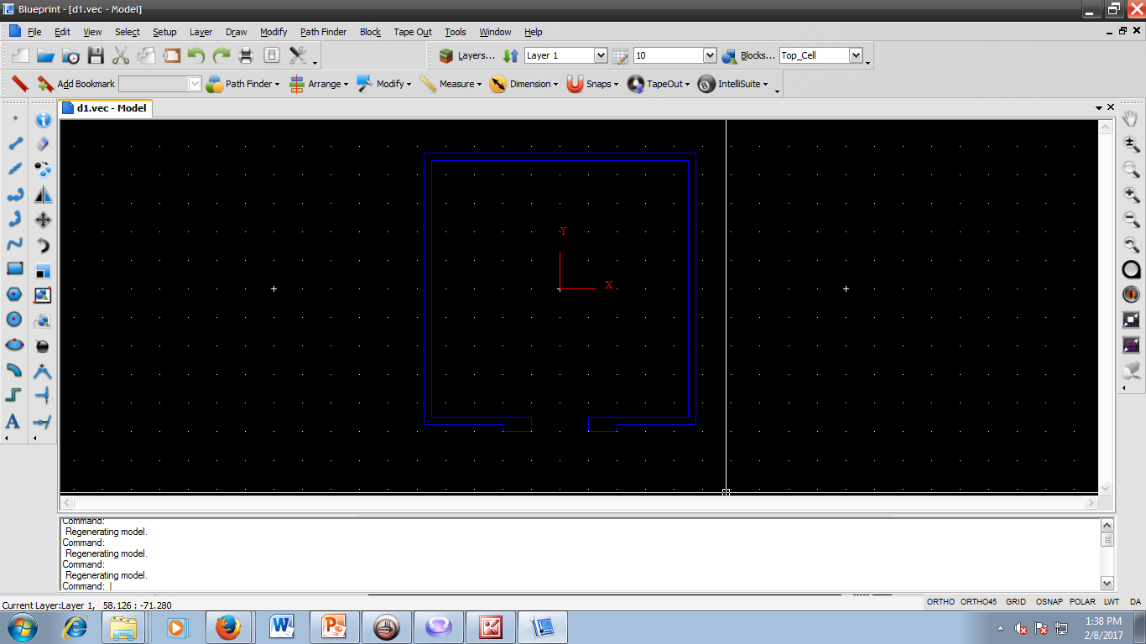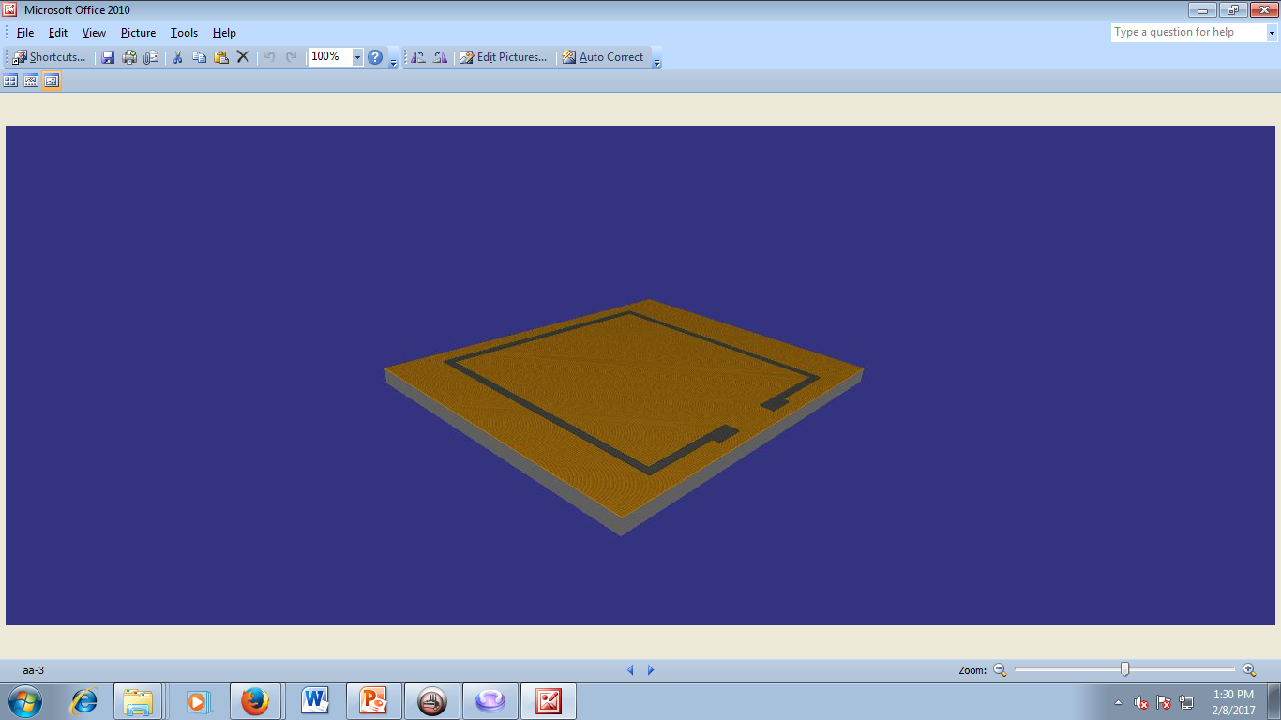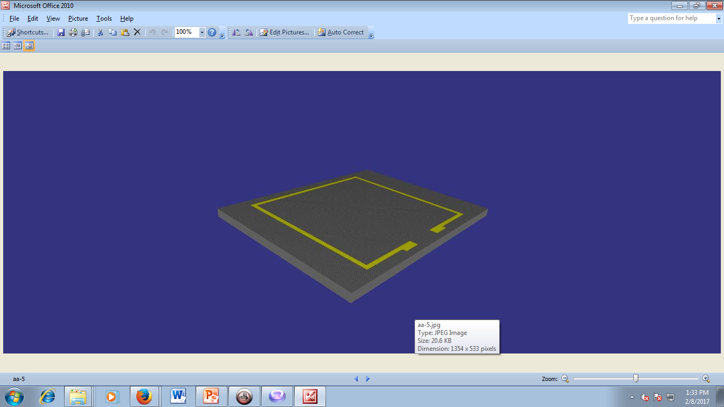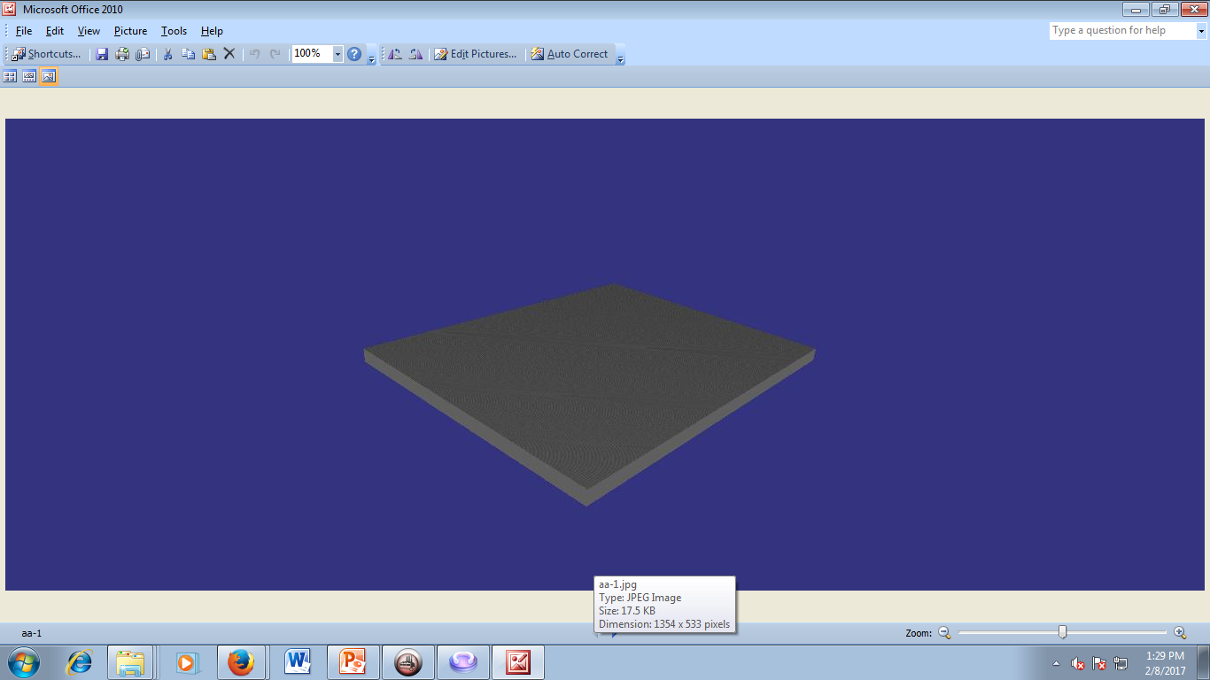

Etching of the photoresist

Deposition of piezoresistive material

Exposing Mask 1 on photoresist (Gold colour)

Defining Silicon substrate

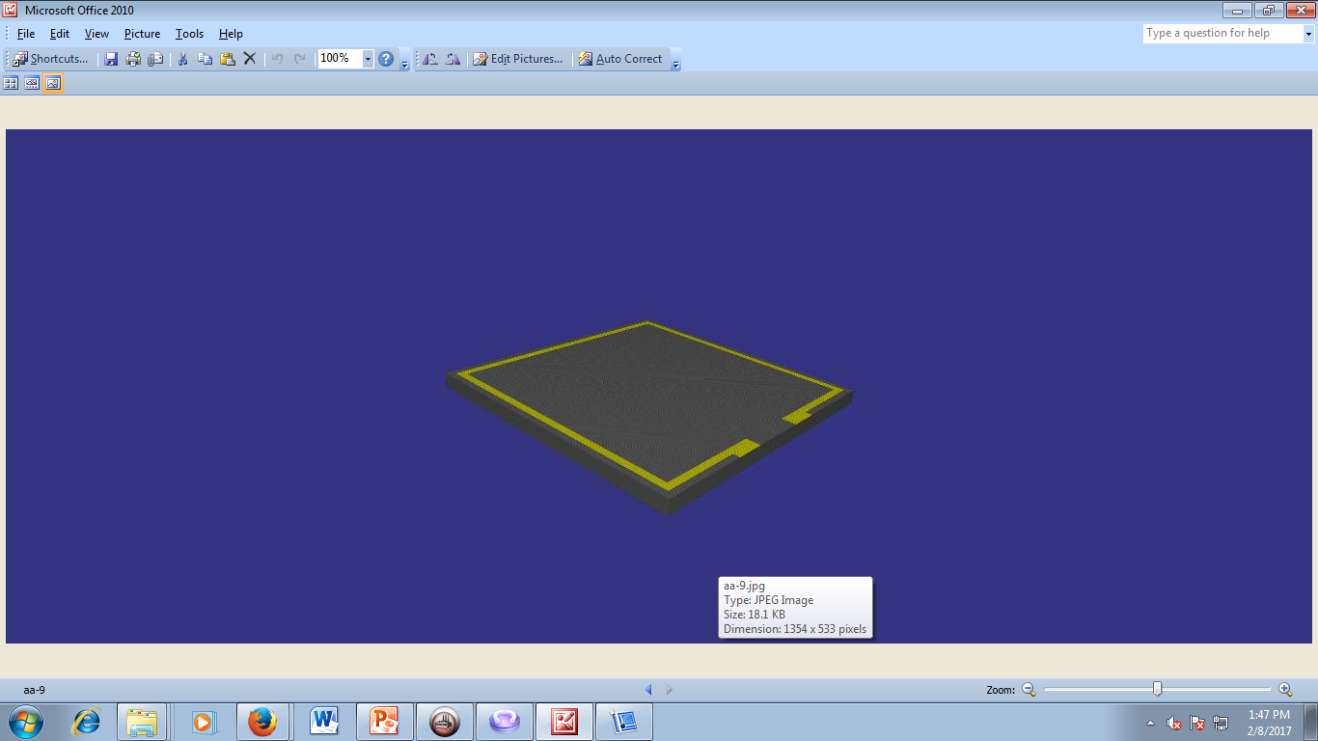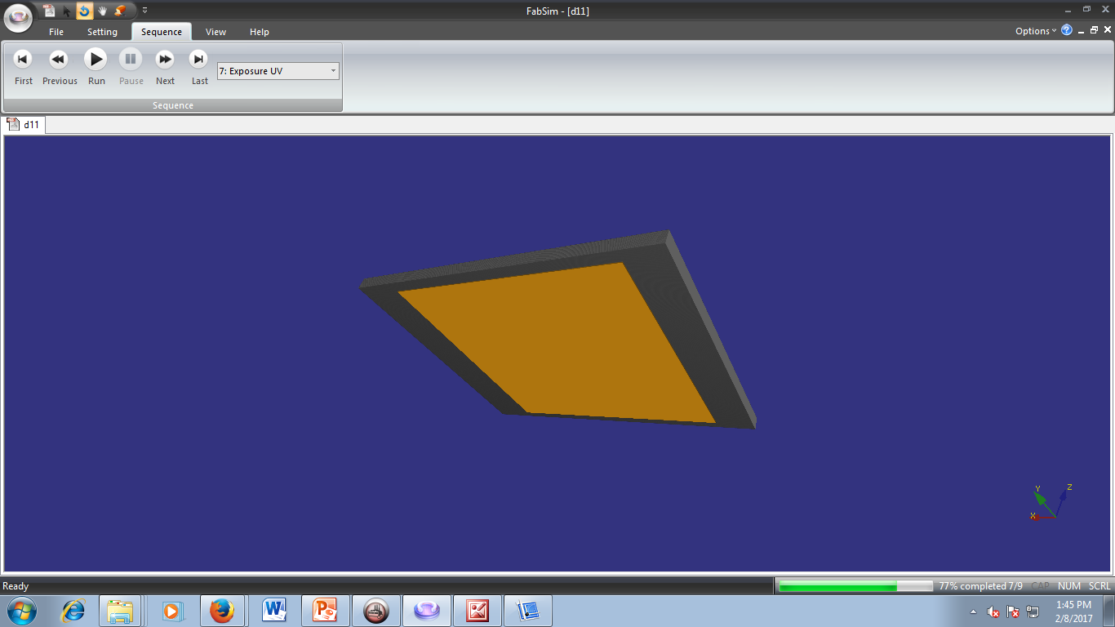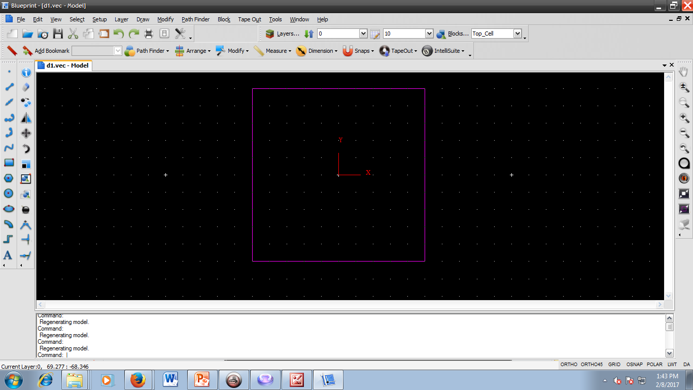

Exposing Mask 2 on photoresist (Gold color)

After etching the extra silicon and the Photoresist